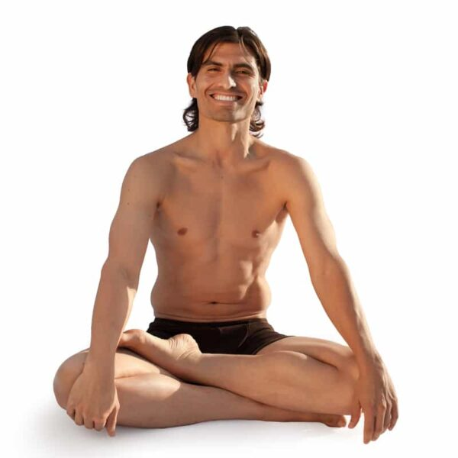

Most Posture Technique Classes will be 2 hours
from time to time we may go over

Wednesday 27th of September – 3pm
Thursday 28th of September – 2.30pm
Monday 2nd of October – 2.30pm
Tuesday 3rd of October – 2.30pm
Wednesday 4th of October – 3:00pm
Thursday 5th of October – 2.30pm
Friday 9th of October – 2.30pm
Wednesday 11th of October – 3pm
Thursday 12th of October – 2.30pm
Monday 16th of October – 2.30pm

